PART D

Screenshot of W3C Validation of HTML & CSS

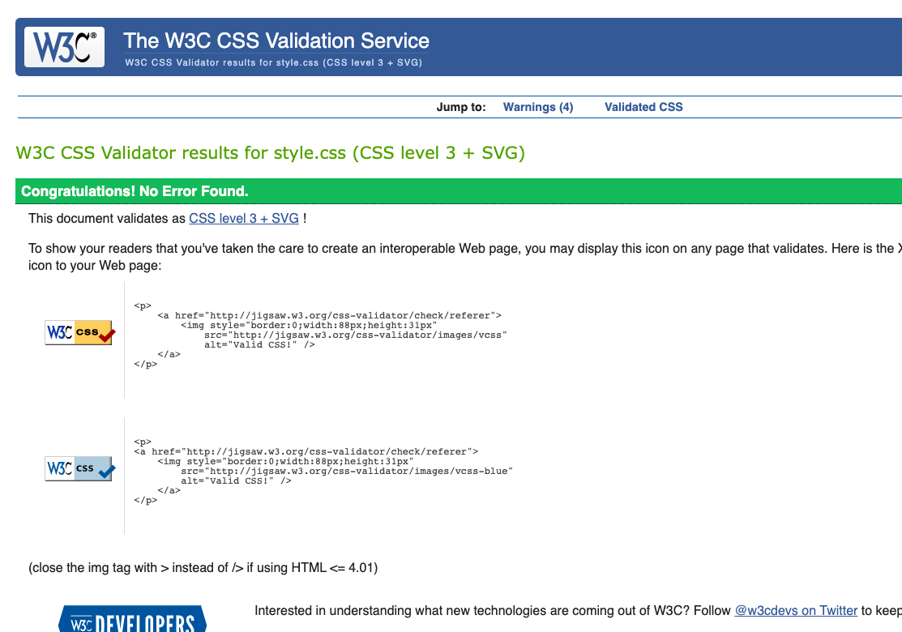

Cross-Browser test three examples including mobile phone

Safari:

Chrome:

Firefox:

Mobile(safari&chrome)

PART E

Confirm how icons chosen for each input are relevant to the type of input being sought.

1. 

This icon I choose for title input hints that it is related to a document, and each document usually has a title;

2. 

This icon I choose for author name show a human figure, which indicates it’s about personal info

This icon I choose for ISBN number is called “barcode”, I choose it because ISBN number usually print on book back with a barcode

This Icon I choose for “sold qty” has an up arrow and 1/9 digit, which indicates it has something to do with number.

What is it that you are trying to convey in the logo design created

This Logo I drew is quite simple but different from other book logos online, it’s quite like a book in real world, I set the border colour different from black, because I want to express that book reading is not that boring, and the lines I use though simple ,it’s quite elegant, which indicates that book reading not just enlarge your knowledge bank , it’s also fun and elegant.

What WHS principles were followed while working on this project

1. I use cmd + tab fast key to switch between VS CODE and Chrome Page, so I don’t need two display monitors, which will make me twisting my head all the time to look at different screens.

2. I will stand up and stretch a bit every 45 mins to avoid sitting in one posture for too long time.

3. I put my knees at the same height or slightly lower than my hips and place my ankles in front of my knees.

4. I use a chair with adequate lower back support.

5. I put my water cup away from my keyboard, in case it flip down and damage my laptop